Understanding AI / ML

* Have table of contact,
* Introduction
  + Goal of this paper
  + About AI/ML
  + Real life examples
  + Why we use it
    - We have a lot of data
    - We have tech tool
    - We have competitives
  + Some resourses and courses (swamay can watch this, etc)
* Show an excel file and ask them to find the pattern, just to show how hard it is
* End the doc with the project we did and how we could’ve improved it

I think this is how to do it:

1. What is ML
2. Real life use cases
   * Why we need it

Differences between Artificial Intelligence and Machine Learning?

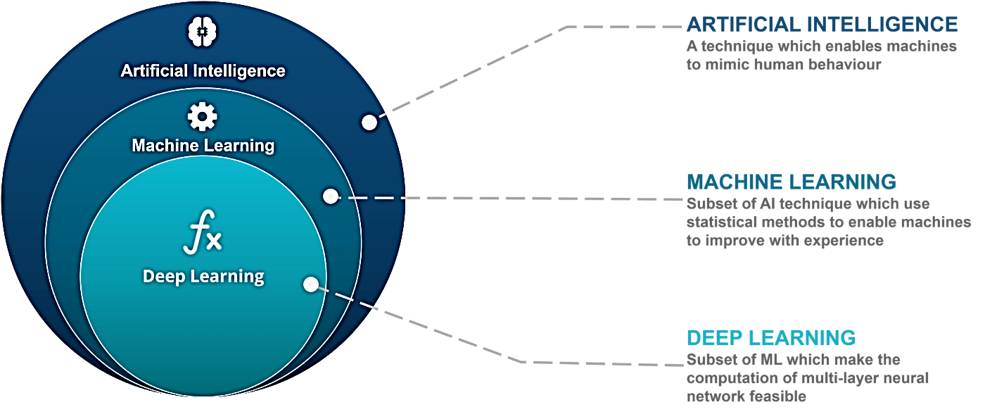

**Artificial intelligence (AI):**

" It is the science and engineering of making intelligent machines, especially intelligent computer programs. It is related to the similar task of using computers to understand human intelligence, but AI does not have to confine itself to methods that are biologically observable."

**Machine Learning (ML):**

"Machine learning is a field of computer science that aims to teach computers how to learn and act without being explicitly programmed. More specifically, machine learning is an approach to data analysis that involves building and adapting models, which allow programs to "learn" through experience."

The focus in this paper is Machine Learning, what it is exactly, why do we need it, machine learning process, application of it, ….(add)

Introduction:

What is Machine Learning?

The power of data

How does human learn any skill?

1. Identify patterns
2. Recognize those patterns when see them again

Example:

* We learn how to read by identify letters 🡪 patterns of letters that from words🡪recognize those patterns (words) when see them again.

How does ML learn?

1. finds patterns in existing data.
2. Uses those patterns to predict the future

Example:

* Detect credit card fraud based on previous credit card transactions
  + Find a pattern in that data, then detect when a new credit card transaction is likely to be fraudulent.

How:

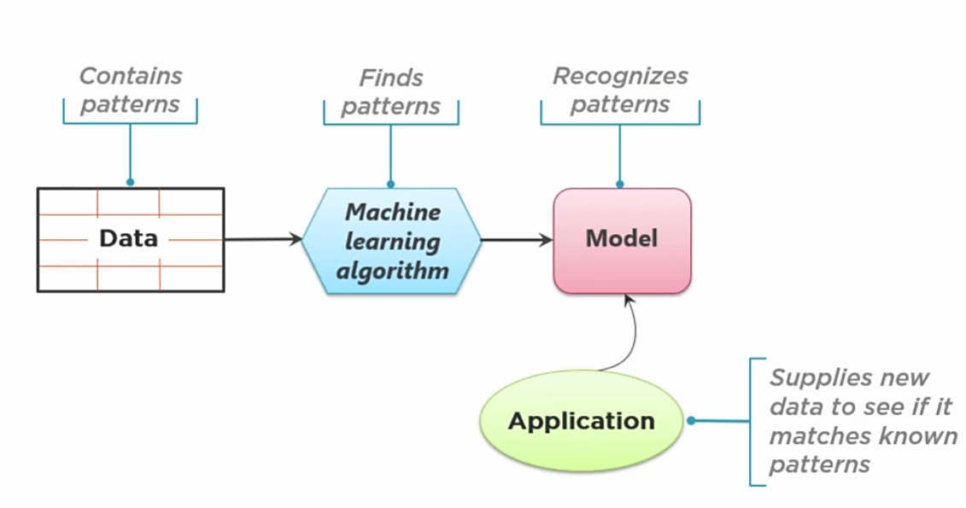

1. Collect/use data that contains patterns.
2. Feed that data into a machine learning algorithm/algorithms.
3. This algorithm finds patterns in the data and generates a model.
4. A model recognizes patterns when presented with new data.
5. Applications can then use that model to perform what it was designed for.

* Explain it in how kids learn.

Why is ML a trend?

* Because now, all factors that is essential for ML is available more than ever:
  + Big data era🡪 lot of data
  + Cloud era🡪lots of computer power
  + Years of research🡪effective ML existing algorithms

Who needs ML:

1. Business leaders 🡪 Do things faster, better, cheaper
2. Software developers 🡪 Build smarter applications using off-shelf ML models (APIs)
3. Data scientists 🡪 Utilize powerful, easy‑to‑use tools.

Challenges:

1. It raises ethical concerns:

* Although the statistical techniques behind the ML models are complex and is not a regular software code that can be understood by looking at it, it is important to understand how the ML model makes that specific decision for protection from any future legal sue.
* Recognizing biased is challenging especially with large data; however, the result of such biased could be critical. For example, a person could be rejected from having a loan because of a racial biased in the data.
  + biased data🡪 biased model 🡪 biased decisions

The ML process:

* Note: the process is iterative and find meaningful patterns in a large amount of potentially complex data is challenging. Although the benefits of successful ML models can be substantial, failure is always possible.

Steps:

Ask the right question:

The first and most important steps in ML process is analyzing the problem

1. Analyze the problem: What is the question I am trying to answer / what is the problem I am trying to solve?
2. Analyze the data: Do I have the right data to answer this question?
3. How to evaluate our ML models decisions (predictions)? How good must those predictions be to make this entire process qualify as a success? (When to stop the process)?

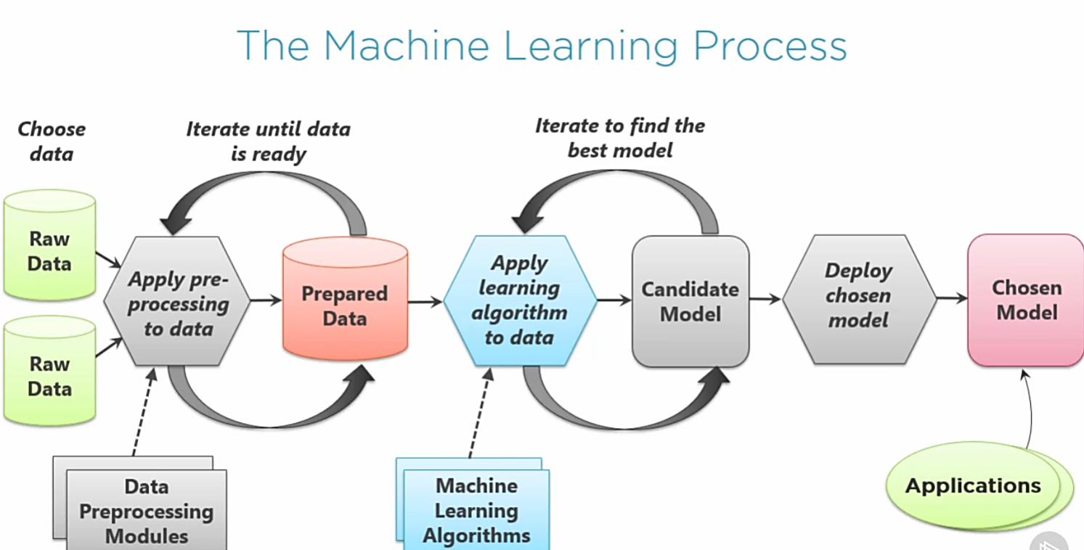

1. Work with expert to choose the right data set, can have data from different sources (mostly not in the right form)
2. Pre‑processing the data. Remove duplicates, check if it has missing data, remove extra data.
3. The result of step 2 is the prepared data that would be input to the ML algorithm. This data set is not final, and it is needed to iterate between steps 2,3 until is ready.

Note: cleaning and preparing data are the most time consuming in the ML process.

1. Training a model which means applying learning algorithms to the data. Most of the time you just use pre-defined algorithms.
2. The result of step 4 is a ML model. You would need to train different models then choose the best one for your case.

* You need to iterate on that data and models until you have a model that makes good predictions.

1. Deploy the chose model.
2. Application then can make a use of this model.

Note: beside those iteration at small levels, there's also iteration at the largest level where you need to repeat the whole process and recreate the ML model over and over. The reason for that is the fact that data, algorithms, etc. Keep changing.

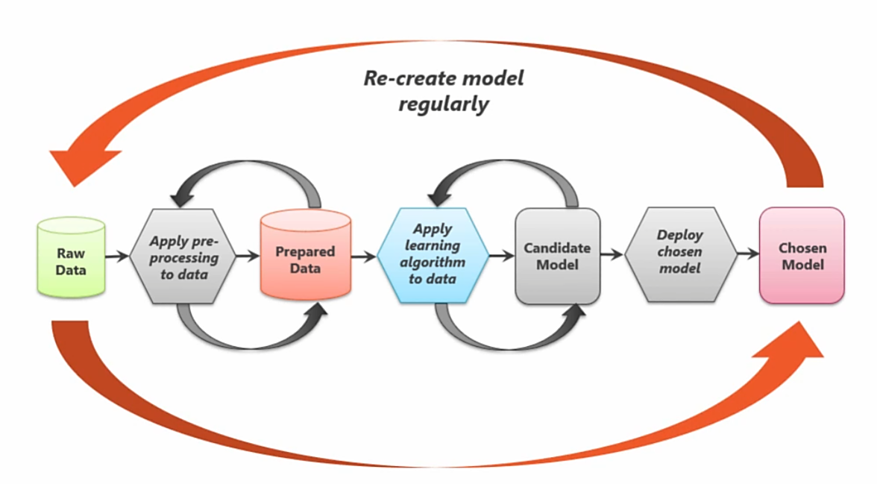

ML application in Real World

[Top 9 Machine Learning Applications in Real World - DataFlair (data-flair.training)](https://data-flair.training/blogs/machine-learning-applications/)

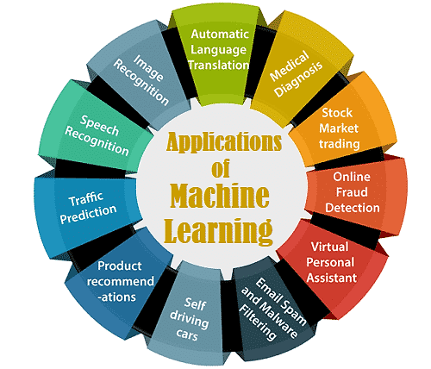

Type of it

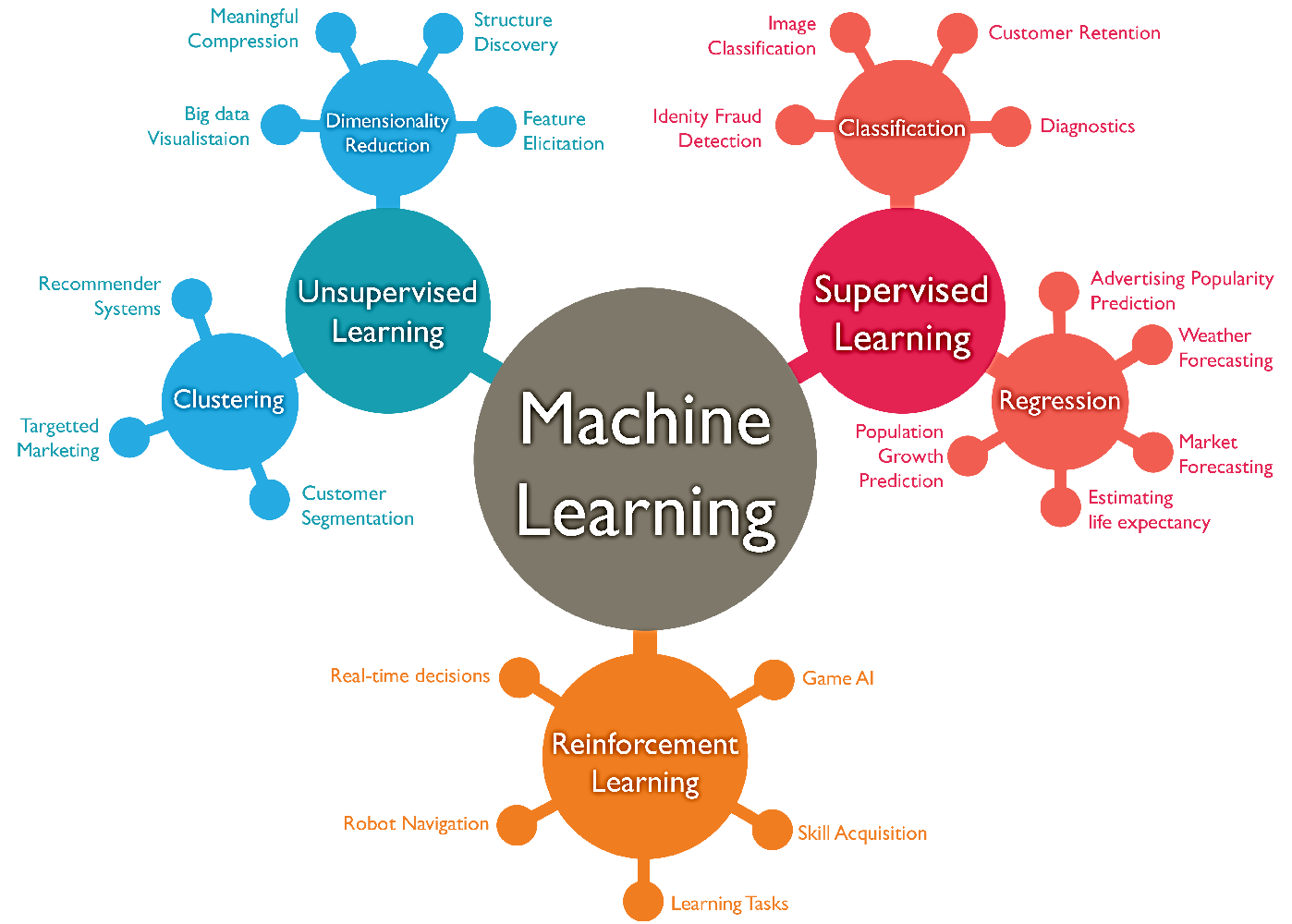

Process to build a model

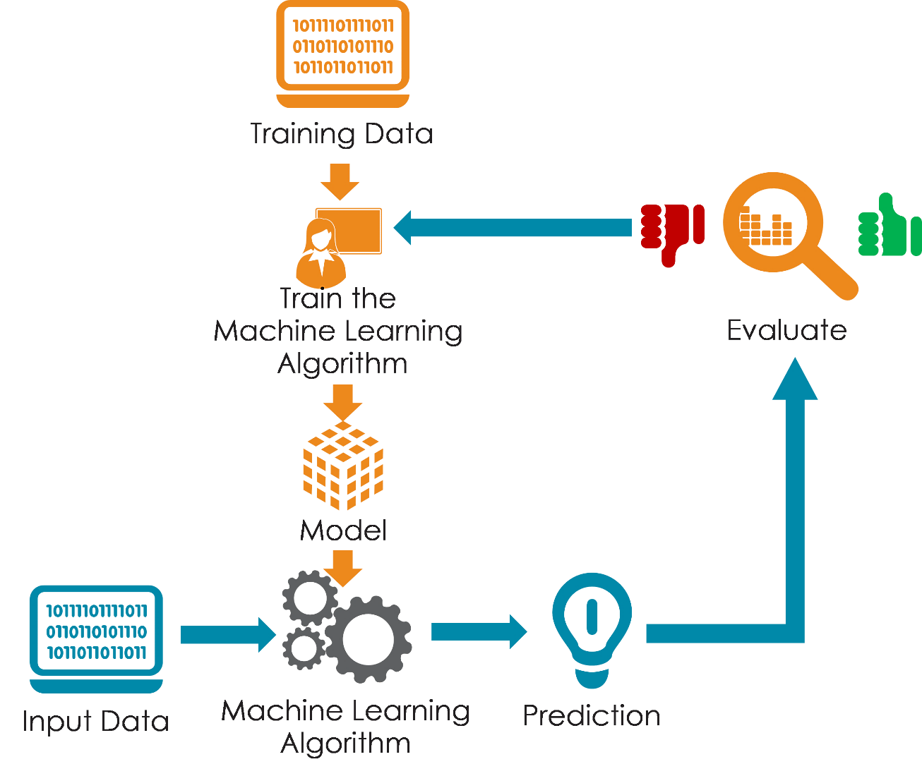

[What is Artificial Intelligence (AI)? | IBM](https://www.ibm.com/cloud/learn/what-is-artificial-intelligence)

[Machine Learning Definition | DeepAI](https://deepai.org/machine-learning-glossary-and-terms/machine-learning)

**Arabic Video**

Video#1[Machine Learning Get Started - Arabic - Mohamed Ezzat - YouTube](https://www.youtube.com/watch?v=0QMdQ84pNbk)

Agenda:

1- What is machine learning and why we need it

2- Real life use cases for machine learning

3- Machine learning fundamentals

4- Overview on Deep learning

5- Tools to start your first machine learning project

Arabs were the first who introduced Cryptology, and they wrote about crypto (التشفير)

* Alkhwarzmi
* Cryptology is the mathematics, such as number theory and the application of formulas and algorithms, that underpin cryptography and cryptanalysis.

**What is ML?**

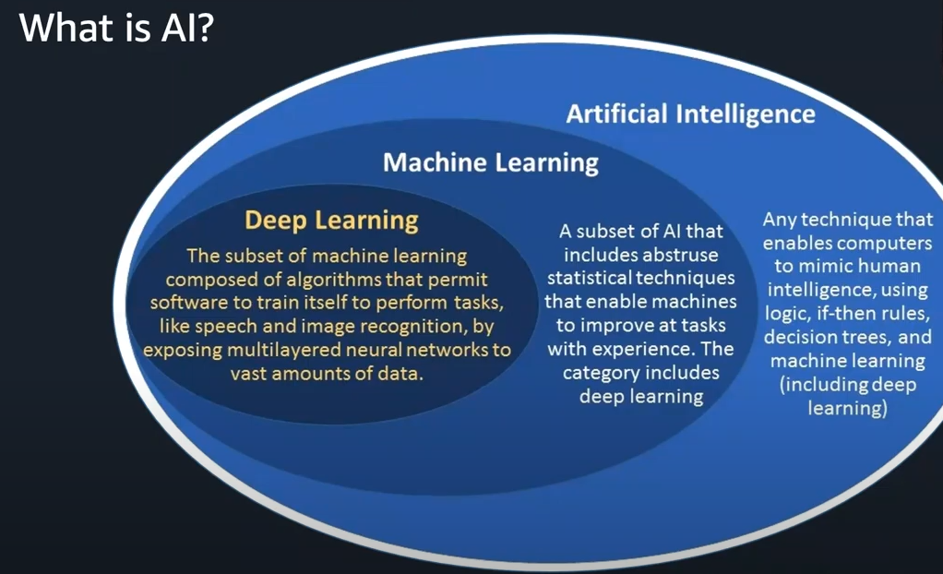

* Ex: I need a program that tells me who is a good driver:
  + Use if statement: if the person has a license and did not have an accident in 3 years, THEN he/she is a good driver
  + Case with simple requirement => no need for training a model
* Ex: I need a program that tells when the email is spam:
  + Using if/else is not the best solution because let’s say you have this logic:
    - If you see the word “pay now” then this is spam, the hackers will modify this word in a way and your application will fail recognizing spam emails.
  + So, we need to train a ML model that can decide without using the simple if/else logic, yet using statistic and probabilities
  + **How**:
    - Have a data of previous emails
    - This data has to be labels.
      * This email is spam
      * This email is not a spam
    - The chosen ML algorithm with find the pattern in those data (Learning)
    - The model now will be able to recognize if any NEW email is spam.
* Ex: I need to recognize if what in the picture is cat or dog (Image recognition)
  + Statistic and probabilities cannot solve this problem, so they introduce a new field (**Deep Learning**) which mimic the way our brain learn.
    - neural networks: A group of nerve tracts connecting a series of regions in the brain. Neural net-works route signals through the brain along a linear pathway, analyzing and organizing different types of information within fractions of a second.
    - محاكاة الدماغ البشري

ML and deep learning were introduced years ago, why is it a hit in the last several years?

1. The data era.
   * Large amount of unused data
2. Computing:
   * GCP, VM (ex. Amazon EC2).
   * Reduce the model’s training time

**Why do we need ML?**

* To solve problems that it is hard to be done with traditional programming techniques. Explain by examples.

**Real life use cases/why we need it**

1. Predict costumers who tend to leave the business and arrange something to keep them.
2. Predict equipment failure.
3. Recommendations in shop sites.
4. Speech recognition
5. Facial recognition
6. Language translation
7. Make personalized recommendation to increase the customers engagement. (ex. Amazon)🡺 $
   * It even open the customers eyes to product/services that they did not know about specially If the company serve a lot of products/services
8. Make faster decisions by automatically extracting and analyzing data from document (ex. Amazon extract):
   * Ex. Instead of going over the forms one by one, getting data and save it in a database which required a lot of time and effort especially if have large amount of data, just use ML to do this.
9. Forecast/predict the demand (ex. Amazon Forecast)
   * Instead of doing a random guess of how many potential demand items/ services, we can use ML to increase the accuracy.
10. Analyze the mode of the person when write a comment. (ex. amazon comprehend)
    * After having many good comments, new comments from unhappy costumers start increasing. The ML can save the business by noting when those comments start to appear, what is the possible reasons for that change. In the case, the owners themselves might not notice that change or the reason for it. So analyze the level of satisfaction of the customer for example.
11. Charm prediction: predict what customers are planning to stop their services, then do something to prevent that.
12. Amazon codeguru:
    * Tells what part of the code has the most cost (time, resources(memory)
13. Amazon Kendra:
    * Search with text: I want a college that has different location, low cost, teach Arabic, and gives a full scholarship.

* Amazon has services that change voice to typed word, the opposite, translate

API vs Building a model from scratch

API🡺 ex. Amazon

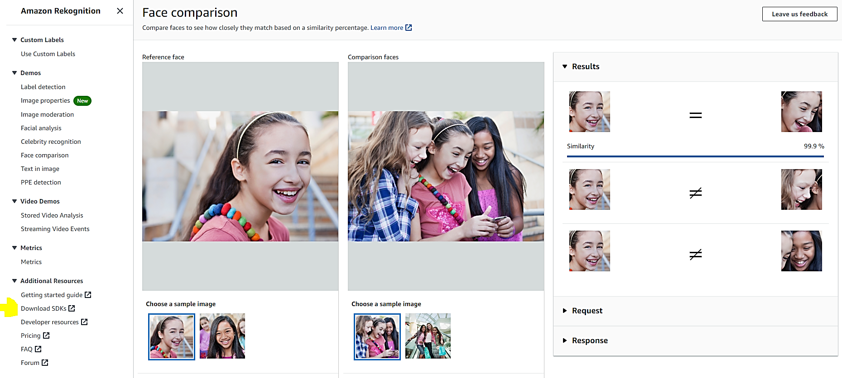

Color yellow: to download the API call (add that snippet to your code)

* Those are services, the value of those APIs is how to use them to achieve your purpose. For example, I my pervious internship, I use the Amazon Rekognition PPE API to detect of the driver of the care is wearing gloves/scarf. Based on the output, the system will make an intelligent decision of turning the heating parts in/off. The purpose of this is to increase the power efficiency and the driver comfort.

Build a model

Terms:

* Anomaly detection:
  + “Anomaly detection is a process in machine learning that identifies data points, events, and observations that **deviate** from a data set’s normal behavior. And, detecting anomalies from time series data is a pain point that is critical to address for industrial applications.”

[What is anomaly detection? - IBM Developer](https://developer.ibm.com/learningpaths/get-started-anomaly-detection-api/what-is-anomaly-detection/)

Ex. The price of a car is 10K. the seller sold it with 12K but enter a 10K to the database.

1. 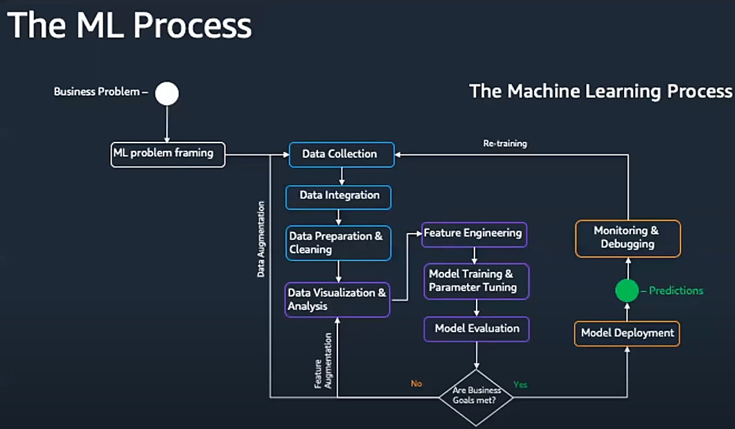

* Data collection:
  + Have the data
* Data integration:
  + Might need to have data from different sources
* **Data prep and cleaning (Good data 🡺 Better ML model) & Data analysis** 
  + Called data massage or data slicing: “massaging, also known as data cleansing or data scrubbing process, is a way to eliminate unnecessary information from data or cleans a dataset to make it useable. It involves processing data to change data formats, remove unwanted characters, duplicates, whitespaces, and more.”
  + Ex:
    - Data that is all zero: Delete it
    - Data that is wrong (ex. Feb,31): Delete it
    - Most of column is zero: is bad, so need to impute it, meaning put a value other than zero, ex. The average or the mean function of it
* Data engineering:
  + Ex:
    - Have balanced data, meaning if you are trying to train a model to tell the difference between a cat and a dog, do not just have a data with only cat pictures, because this imbalance data will make the model be excellent when it comes to detect cat, but will fail to detect dog (thing about teaching a kid this)
    - Convert category to one hot encoding. ML just understand the label when they are in 0s and 1s, so if have a category, you need to change it. Ex. We cannot have the label as “Marred, single, divorced, ect.”, but we can have it as 001, 110, 10, 1(this is just to random numbers)

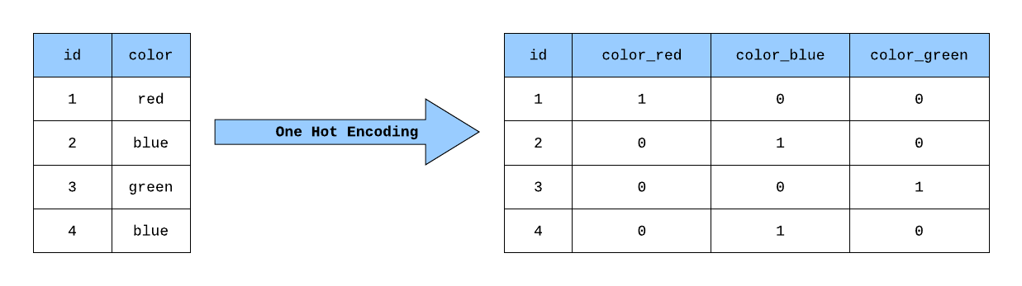

* Training:
  + After having the data cleaned, enter it to the chosen algorithm (find the pattern)
* Evaluation:
  + Test your model by giving it a new data that did not see before (note that you have the right result of it), then compare the model output with the correct output you have🡺model need to recognize the pattern when sees a new data

Ex. This is the behind scene of the Amazon website personalization (have special recommendation for each user)

* Enter the user dada in csv format
* Data will be checked
* Hyper parameter (the weight_ can find it under the deep learning section)
* Train, optimize the model then give you a end call where you pass the user name, and get back the best recommendation for him/her

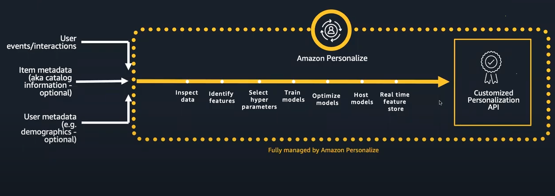

**Build a ML**

Amazon SageMaker:

* It provides the infrastructure and all tools/packages/libraries such as tensor flow, Jupyter notebook that are needed for building a ML model

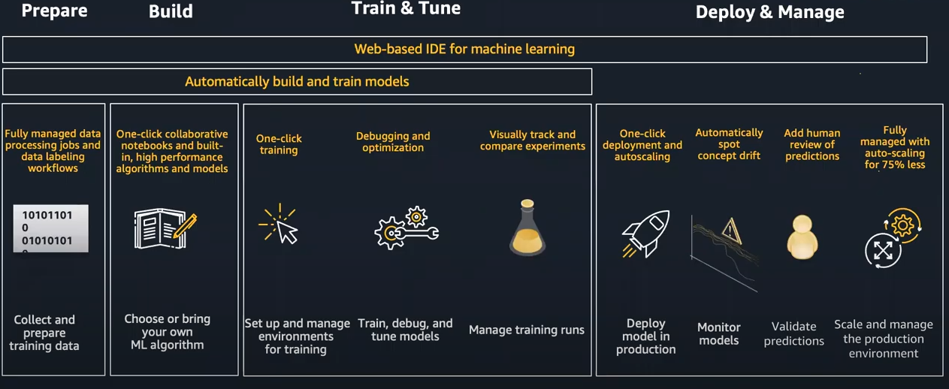

**Deep Learning**

* **Biological Neuron**:
  + Our brain (the nerve cell):
    - Ex#1: when you start driving, there is a neuron in your brain that gets activated (تحفز ) whenever the eyes see something, and there is another neuron that linked to the leg, so when this neuron gets activated, the leg will move. Now, when you start driving, the connection between those two neurons will not be strong, so sometimes you might see a stop sign and instead of putting your legs on break, you put it on gas. After a while, you reach the optimal connection between those neurons, and you start driving without thinking much about it.
    - Ex.2: When the smell or see a delicious food, the neuron in your brain got activated, send an electrical single to the neuron that responsible for feeling hungry so it got activated as well.
      * So the neuron for feeling hungry was set on fire (got activated) when the input (the smell) neuron was activated (smell good foods)
    - **Note** that if the object the eye sees is not important when driving or if the smell is bad, the neuron that associated with it will not be activated in the first place, so no further action will happen.
* **ML Neuron network:**

**Regression model:**

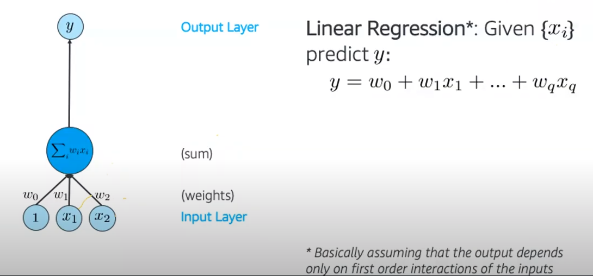

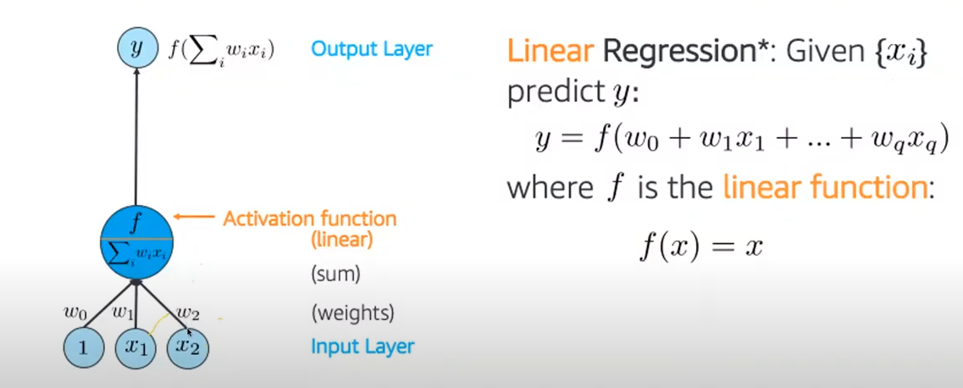

Note: The neuron has a function 🡺if the input start firing the neuron, it will send a signal (will see later what will do with this signal)

* Ex: you want to build a neuron network to tell if the student is a “A” student or not. So, will have two inputs: if attend all lectures, if did all homework.
  + If they attend all lectures and did all homework.
  + If attend 90 % of lectures and did 3 homework.
  + If attend 80 % of lectures and did 5 homework.
* Note how the input change, so we need something called weight (w)_called hyper parameter as well, **this is the most important factor and what the neuron network work on to find, this is the attempt to find the perfect connection(remember the example of driving) that give me the best results.** What happened is the following:
  + You enter the previous data of students and based on your knowledge you enter who ended up having “A” or who not.
  + The neuron network will keep processing your data and will end up determining that those who attend 80% of letters and finish 3 homework will end up being good students:
    - So, the weight for x1 will be 70%, x2 is 3
  + Y is the function that determine if those input is causing the activation (smell good, red sign, above 70 % and 3 homework. If result is 1, then those input cause firing in the neuron.
  + Note: as we dot not know the weight for each input when start this process, we just choose a random number then the model will alter it as needed.
* NOTES:
  + Here we needed two neurons + the w1 to enter the input. For image recognition, if the size of image is 28*28, then would need 28*28=784 just to enter the input (big numbers of input🡺need layer of neuron)
  + Our eye has different layer of neuron, in each layer there are about 5-10 billion of neuron!!!
  + How many layers, and how many neurons??
    - There is no one answer, but there is a typical network that you can follow for image recognition for example. Etc.

**Multilayers network:**

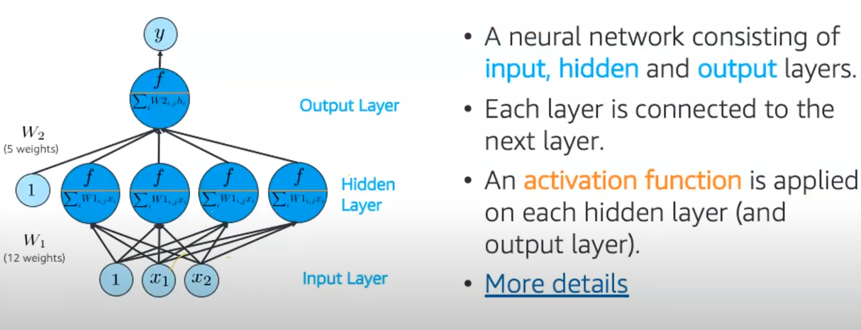

**Road map for ML**

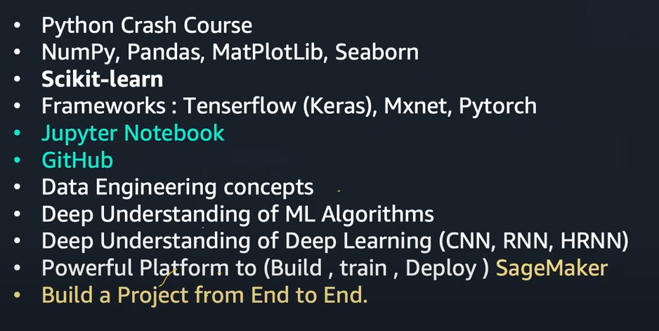

* **The second line: libraries (this is a core thing in data science and ML)**
  + NumPy: deal with array
  + Pandas: deals with framework
  + MatPlotLib & Seaborn: deals with visualization
* Scikit-learn (ski learn):
  + Divide your data randomly to training, testing, validation sets
  + Change the categories to one hot encoding
* Keras is a layer on top of Tenserflow to make it easier for user
* Check udemy courses for the first two
* Skit learn, check their page, and check amazon free course
* End of video, will cover some aws ML

Stop 1;49

My case:

Tend to divorce

Lose interest

About to change a major

Commit a suicide

Hurt someone

* Check the GCP services

[AI & Machine Learning Products  |  Google Cloud](https://cloud.google.com/products/ai/)

* Check ChatGPT